Product Inventory System
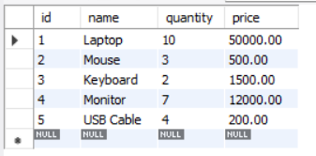
Tasks:
- Find low stock products (quantity < 5:
SELECT *
FROM products
WHERE quantity < 5;
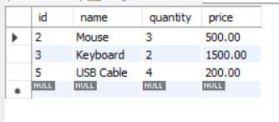
- Calculate total inventory value:
SELECT SUM(quantity * price) AS total_inventory_value
FROM products;
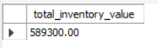
- Update stock after sale:
UPDATE products
SET quantity = quantity – 2
WHERE name = 'Mouse';
